Decision Trees

2. *How and why are these numbers related in the pruned and unpruned cases?* [1 mark]

pruned:
- Number of Leaves : 61
- Size of the tree : 93
- Correctly Classified Instances 210 90.5172 %

unpruned:
- Number of Leaves : 121
- Size of the tree : 175
- Correctly Classified Instances 201 86.6379 %

In pruned tree we removed sections of the tree that provide little power to classify instances, because of this the size of the tree is smaller. Pruning also reduces the complexity of the final classifier, and hence improves predictive accuracy by the reduction of overfitting. We can see more correctly classified instances in case of pruned tree.

Data Proportions with MaxEnt + Naïve Bayes

4. What accuracy is the minority class detected with for the test data,
and what other class is it confused with? [1 mark]

0.2000 is the accuracy of the minority class detected with for the test data.
This situation happened because the 3d class in 2-dimensional plot (in 2 dimentions) looks very close to the 2d class. We use not enough dimensions.

5. What is the new accuracy for class 3? What happened here? [1 mark]

0.1200 is the new accuracy. 22 items actually the 2d class, but they predicted to be the part of the 3d class. This happened because flower frequency changed. As usual, the minority class is likely to be misclassified.

8. What prior should you set to get maximum accuracy in country B? What accuracy do you get by setting this? [1 mark]
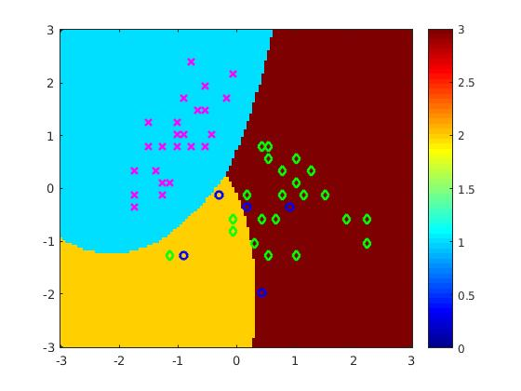
The highest I get is:
train acc: 0.89
Test acc: 0.91

using 4/10, 2/10, 4/10
assuming in cell 4, line 46
.....&(mod((1:N)',5)==0));

Scaling with # of dimensions (Aka Attributes, Features)

4. *What happened here?* [2 marks]

LR Train acc: 1.00
LR Test acc: 0.86
NB Train acc: 1.00
NB Test acc: 1.00

The common theme of these problems is that when the dimensionality increases, the volume of the space increases so fast that the available data become sparse, which prevents common data organization strategies from being efficient (curse of dimensionality case). In order to obtain a statistically sound and reliable result, NB need for data sets that scale exponentially with the number of features. In our case NB simply does not work properly.

